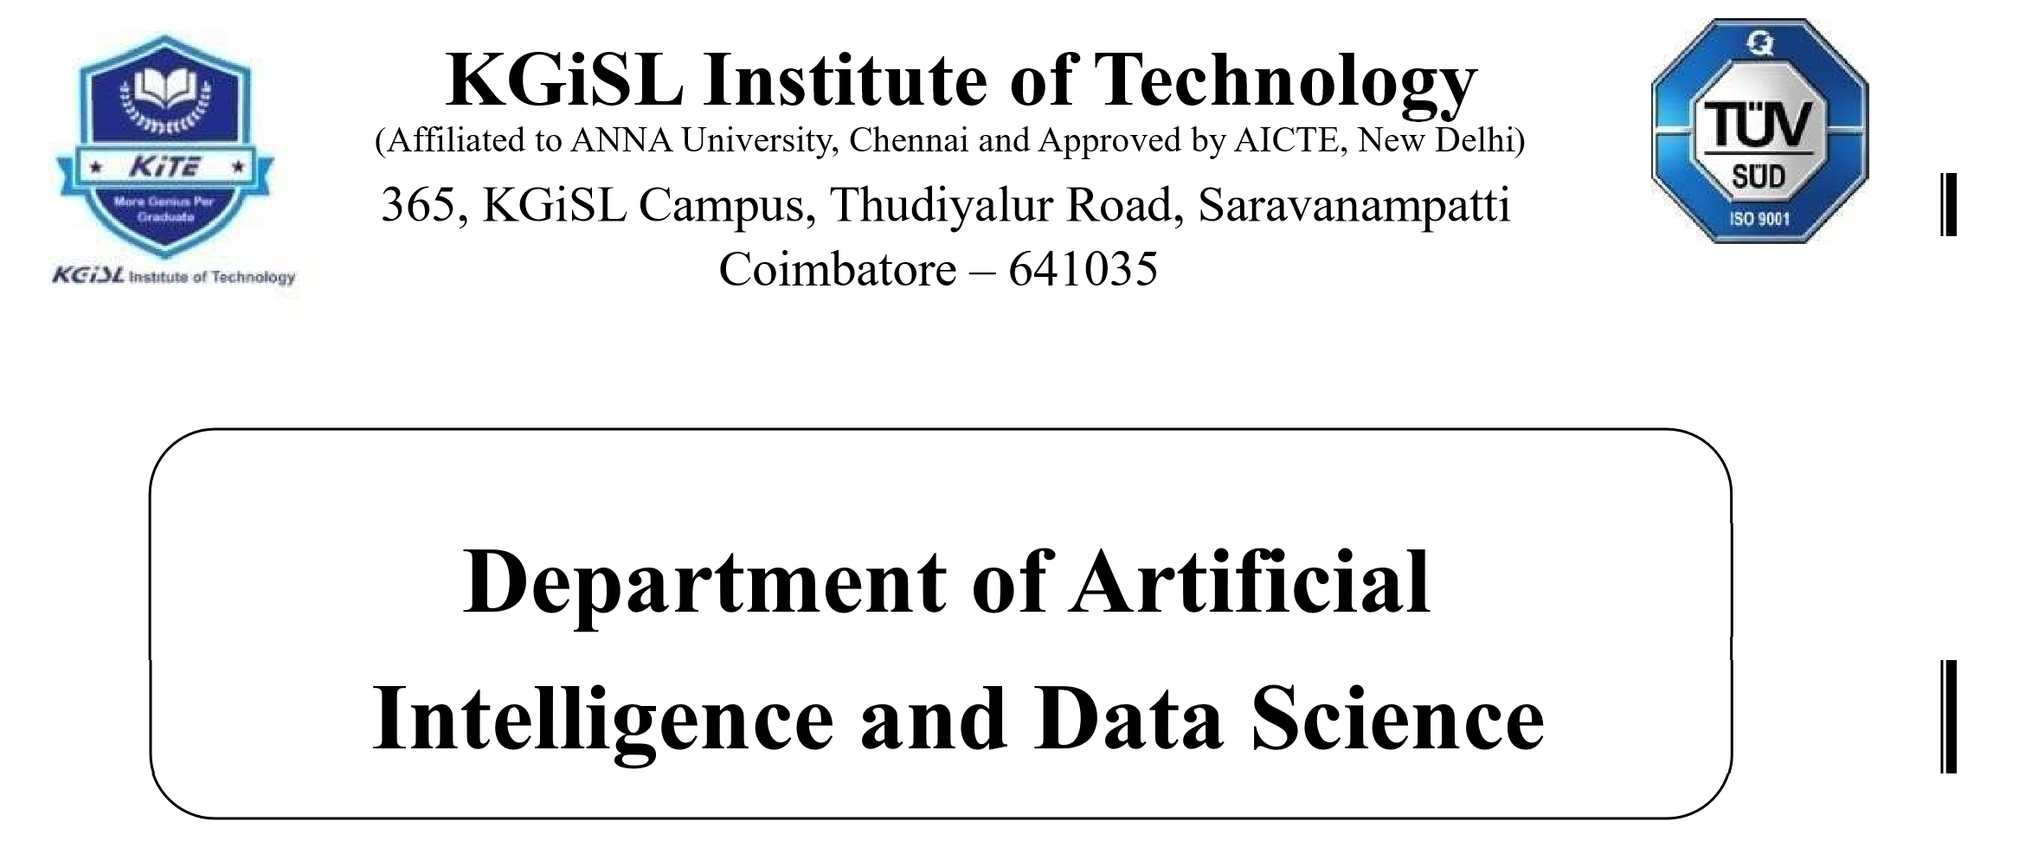

Naan Mudhalvan -IOT

# Problem Statement: Public Transport Optimization

MENTOR NAME: EVALUATOR NAME:

Mr.MOHANKUMAR.M Ms.AKILANDESWARI.M

**Problem Statement:**

The IoT-Based Public Transport Optimization project aims to design, develop,  and deploy an innovative in a rapidly growing urban environment with increasing congestion and pollution concerns, the current public transportation system faces significant inefficiencies and challenges. High passenger demand during peak hours results in overcrowded buses and trains, long waiting times, and irregular schedules. Inefficient route planning, outdated infrastructure, and inadequate integration between different modes of transportation further exacerbate the problem. The objective of this project is to develop and implement a comprehensive public transport optimization strategy that addresses these issues, aiming to enhance the accessibility, reliability, and sustainability of the public transport system while minimizing operational costs and environmental impacts. This optimization effort should prioritize the reduction of passenger wait times, the improvement of service reliability, and the reduction of carbon emissions, ultimately making public transportation a more attractive and competitive choice for urban commuters.

**Design thinking process:**

1. **Empathize:**

* Begin by understanding the needs and pain points of the various stakeholders, including commuters, public transport agencies, and local government officials.
* Conduct surveys, interviews, and observations to gather insights into the specific challenges faced by passengers and the limitations of the current system.

1. **Define:**

* Clearly define the problem by synthesizing the collected data and insights. Identify the most critical pain points and opportunities for improvement.
* Create personas or user profiles representing different types of commuters to better understand their unique needs and preferences.

1. **Ideate:**

* Generate a wide range of ideas for improving public transport optimization. Encourage brainstorming sessions with cross-functional teams that include transportation experts, urban planners, and technology specialists.
* Use creative thinking techniques such as mind mapping and brainstorming to explore innovative solutions.

**4.Prototype:**

* Develop rough prototypes or concepts based on the most promising ideas. These can include physical mock-ups, digital simulations, or process flow diagrams.
* Test these prototypes with a small group of commuters to gather feedback and refine the concepts.

**5.Test:**

* Implement pilot projects or small-scale tests of the refined concepts in a real-world setting. This could involve modifying routes, schedules, or introducing new technologies.
* Gather data and feedback during the testing phase to evaluate the effectiveness and user satisfaction of the proposed solutions.